

|  |  |  |
| --- | --- | --- |
| **Computer network** | | |
| Lab Manual | | |
| **Department of Computer Science and Engineering**  **The NorthCap University, Gurugram** | | |
|  | |
|  | |
|  | |
|  | |
|  |

**Computer Network Lab Manual**

**CSL 304**

**Dr. Shilpa Mahajan**



Department of Computer Science and Engineering

NorthCap University, Gurugram- 122001, India

Session 2019-20

*Published by:*

**School of Engineering and Technology**

**Department of Computer Science & Engineering**

**The NorthCap University Gurugram**

**• Laboratory Manual is for Internal Circulation only**

**© Copyright Reserved**

*No part of this Practical Record Book may be*

*reproduced, used, stored without prior permission of The NorthCap University*



Copying or facilitating copying of lab work comes under cheating and is considered as use of unfair means. Students indulging in copying or facilitating copying shall be awarded zero marks for that particular experiment. Frequent cases of copying may lead to disciplinary action. Attendance in lab classes is mandatory.

Labs are open up to 7 PM upon request. Students are encouraged to make full use of labs beyond normal lab hours.

**PREFACE**

Computer Network Lab Manual is designed to meet the course and program requirements of NCU curriculum for B.Tech III year students of CSE branch. The concept of the lab work is to give brief practical experience for basic lab skills to students. It provides the space and scope for self-study so that students can come up with new and creative ideas.

The Lab manual is written on the basis of “teach yourself pattern” and expected that students who come with proper preparation should be able to perform the experiments without any difficulty. Brief introduction to each experiment with information about self-study material is provided. The laboratory exercises will include familiarization with Packet Tracer for simulating network. Students would require to design different network topology and do communication. At the start of each experiment a question bank for preparation and practice is suggested which may be used to test the basic understanding of the students about the experiment. Students are expected to come thoroughly prepared for the lab. General disciplines, safety guidelines and report writing are also discussed.

The lab manual is a part of curriculum for The NorthCap University, Gurugram. Teacher’s copy of the experimental results and answer for the questions are available as sample guidelines.

We hope that lab manual would be useful to students of CSE, IT, ECE and BSc branches and author requests the readers to kindly forward their suggestions / constructive criticism for further improvement of the work book.

Author expresses deep gratitude to Members, Governing Body-NCU for encouragement and motivation.

**Authors**

**The NorthCap University**

**Gurugram, India**

|  |  |  |  |
| --- | --- | --- | --- |
| **CONTENTS** | | | |
| S.N. | **Details** | Page No. | |
|  | **Syllabus** |  | |
| 1 | **Introduction** |  | |
| 2 | **Lab Requirement** |  |
| 3 | **General Instructions** |  |
| 4 | **List of Experiments** |  |
| 5 | **List of Flip Assignment** |  |
| 6 | **List of Projects** |  |
| 7 | **Rubrics** |  |
| 8 | **Annexure 1 (Format of Lab Report)** |  |
| 9 | **Annexure 2 (Format of Lab Certificate)** |  |

**SYLLABUS**

|  |  |  |  |  |
| --- | --- | --- | --- | --- |
| 1. **Department:** | | **Department of CSE & IT** | | |
| 1. **Course Name:**   Computer Network | | 1. **Course Code** | 1. **L- P** | 1. **Credits** |
| **Code: CSL242** | 1 - 3 | 2.5 |
| 1. **Type of Course (Check one):** | | Programme Core Programme Elective Open Elective  **✓** | | |
| **✓**   1. **Frequency of offering (check one):** Odd Even Either Sem. Every Sem. | | | | |
| 1. **Brief Syllabus:**   This course is designed to provide a complete overview of computer networking and covers everything from the fundamentals of networking technologies and protocols to practical applications. The course builds the basic concepts starting with the OSI reference model and progress to elaborate on the protocol stack that is used in traditional networks. The goals, design principles and implementation at different layers of a network are covered to provide a sound foundation on the subject. After going through this course, the student will be able to set up a basic home network, configure devices for connectivity, understand how communication takes place on a network, and what minimal best practices should be implemented to secure the network. | | | | |
| 1. **Total lecture and Practical Hours for this course**   **50 Hours**  The class size is maximum 30 learners. | | | | |
| 1. **Course Outcomes (COs)**   Possible usefulness of this course after its completion i.e. how this course will be practically useful to him once it is completed | | | | |
| **CO 1** | Describing computer network in terms of a layered model. | | | |
| **CO 2** | Implementing data link, network and transport layer protocols in a simulated networking environment | | | |
| **CO 3** | To determine different types of errors and data flow within networks. | | | |
| **CO 4** | Planning logical sub-address blocks with a given address block. | | | |
| **CO 5** | . Describing the standard protocols involved with TCP/IP based communications. | | | |
| 1. **UNIT WISE DETAILS No. of Units: 6** | | | | |
| **Unit I : Network Basics** **Hours:10**  Introduction to network topologies, OSI Reference Model, TCP/IP Model. Transmission media- guided and unguided, Switching-Circuit Switching (space division switch and time division switch), Message Switching, Packet Switching and their comparisons. Hubs, Switches, Bridges, Routers and Gateway | | | | |
| **Unit II : Physical Layer** **Hours: 5**  Digital Signals, Analog Signals, Transmission Impairment, Nyquist Bit rate, Shannon Capacity, performance, Line coding Schemes | | | | |
| **Unit III : Data Link Layer and MAC Layer** **Hours:15**  Character and Bit Oriented Framing, Error Control, Flow Control, Error Detection and Correction , Stop and Wait Protocol, Sliding Window Protocol and Piggybacking, Random Access Protocols-ALOHA, CSMA CSMA/CD,CSMA/CA. Controlled Access Protocols- Token Passing and polling. Channelization Protocols-FDMA,TDMA and CDMA | | | | |
| **Unit IV : Network Layer Hours:10**  Internet Protocol, IP Addressing, IP address classes, Subnet Addressing, Internet Control Protocols: ARP, RARP, ICMP. Virtual circuit and Datagram subnets**,** Routing algorithms, Congestion Control: Principles of Congestion Control, Congestion prevention policies.IPV4 issues, Need for IPV6, IPV6 Addressing and its types, IPV6 Unicast and multicast Addressing | | | | |
| **Unit V : Transport and Application Layer Hours:10**  Transport Services, Connection management, TCP and UDP protocols, DNS, Electronic Mail- SMTP, POP and IMAP,DHCP,FTP | | | | |
| 1. **Guided Project (No. of Hours): NA**   **Unguided Project (No. of Hours): NA** | | | | |
| 1. **Brief Description of Self-learning component by students (through books/resource material etc.): Topics: SDN , ACL, Network Security** | | | | |
| 1. **Books Recommended:**   **Text Books**:   * Behroz Forouzan, " Data Communication and Networking",TMH.,5th Edition,2012 * Tanenbaum, " Computer Network",Pearson, 5th Edition,2013   **Reference Books**:   * [James Kurose](https://www.amazon.com/s/ref=dp_byline_sr_book_1?ie=UTF8&field-author=James+Kurose&search-alias=books&text=James+Kurose&sort=relevancerank) , “Computer Networking: A Top-Down Approach”,Pearson , 7th Edition,2017   **Reference websites:**  <https://nptel.ac.in/courses/106105081/> | | | | |

1. **INTRODUCTION**

That ‘learning is a continuous process’ cannot be over emphasized. The theoretical knowledge gained during lecture sessions need to be strengthened through practical experimentation. Thus practical makes an integral part of a learning process.

The purpose of conducting experiments can be stated as follows:

* To familiarize the students with the basic concepts, programming skill development and the take home laboratory assignments mainly implementation-oriented which have to be coded in high level language. The lab sessions will be based on exploring the concepts discussed in class.
* Observing basic structure and characteristics of Computer Network
* Reporting and analyzing the complexities.
* Hands on experience on the experimental setup and software tools

1. **GENERAL INSTRUCTIONS** 
   1. **General discipline in the lab**
   * Students must turn up in time and contact concerned faculty for the experiment they are supposed to perform.
   * Students will not be allowed to enter late in the lab.
   * Students will not leave the class till the period is over.
   * Students should come prepared for their experiment.
   * Experimental results should be entered in the lab report format and certified/signed by concerned faculty/ lab Instructor.
   * Students must get the connection of the hardware setup verified before switching on the power supply.
   * Students should maintain silence while performing the experiments. If any necessity arises for discussion amongst them, they should discuss with a very low pitch without disturbing the adjacent groups.
   * Violating the above code of conduct may attract disciplinary action.
   * Damaging lab equipment or removing any component from the lab may invite penalties and strict disciplinary action.
   1. **Attendance**

* Attendance in the lab class is compulsory.
* Students should not attend a different lab group/section other than the one assigned at the beginning of the session.
* On account of illness or some family problems, if a student misses his/her lab classes, he/she may be assigned a different group to make up the losses in consultation with the concerned faculty / lab instructor. Or he/she may work in the lab during spare/extra hours to complete the experiment. No attendance will be granted for such case**.**
  1. **Preparation and Performance**
* Students should come to the lab thoroughly prepared on the experiments they are assigned to perform on that day. Brief introduction to each experiment with information about self study reference is provided on LMS.
* Students must bring the lab report during each practical class with written records of the last experiments performed complete in all respect.
* Each student is required to write a complete report of the experiment he has performed and bring to lab class for evaluation in the next working lab. Sufficient space in work book is provided for independent writing of theory, observation, calculation and conclusion.
* Students should follow the Zero tolerance policy for copying / plagiarism. Zero marks will be awarded if found copied. If caught further, it will lead to disciplinary action.
* Refer **Annexure 1** for Lab Report Format

1. **LIST OF EXPERIMENTS**

|  |  |  |  |
| --- | --- | --- | --- |
| **S. No.** | **Objective** | **Page No.** | **Sign.** |
| 1. | To construct a simple network topology on Packet Tracer. |  |  |
| 2. | To verify and configure VLAN and VLAN trunk in packet tracer. |  |  |
| 3. | To construct RJ45 cable. |  |  |
| 4. | 1. To configure simple static routing.   b) To implement Security on interconnecting devices. |  |  |
| 5. | To configure a Network Topology constitutes Routers and Switches using Packet Tracer. |  |  |
| 6 | Working with complex network topologies. |  |  |
| 7. | Mid Term Evaluation |  |  |
| 8. | To monitor network traffic using Wire Shark |  |  |
| 9. | To get the MAC or Physical Address of the system Using Address Resolution Protocol. |  |  |
| 10. | To Configure network using Routing Information Protocol (RIP) |  |  |
| 11 | To configure network state routing protocol (OSPF). |  |  |
| 12 | To configure Border Gateway Protocol. |  |  |
| 13 | To configure Application Layer protocols: DHCP and DNS. |  |  |
| 14 | End term Evaluation |  |  |

1. **RUBRICS**

|  |  |
| --- | --- |
| **Marks Distribution** | |
| **Continuous Evaluation(50 Marks)** | **End Semester Exam (20 Marks)** |
| Each experiment shall be evaluated for 10 marks and at the end of the semester proportional marks shall be awarded out of 50. | End semester practical evaluation including Mini project (if any) carries 20 marks. |
| Following is the breakup of 10 marks for each  **4 Marks**: Observation & conduct of experiment. Teacher may ask questions about experiment.  **3 Marks:** For report writing  **3 Marks:** For the 15 minutes quiz to be conducted in every lab. |

**Annexure 1**

**Computer Network**

**(CSL 304)**

Lab Practical Report



Faculty name : Akansha Kapoor

Student name : Hitesh Sharma

Roll No. : 18CSU086

Semester: V

Group: A2

Department of Computer Science and Engineering

NorthCap University, Gurugram- 122001, India

Session 2019-20

**INDEX**

|  |  |  |  |  |  |  |  |
| --- | --- | --- | --- | --- | --- | --- | --- |
| **S.No** | **Experiment** | **Page No.** | **Date of Experiment** | **Date of Submission** | **Marks** | **CO Covered** | **Signature** |
|  |  |  |  |  |  |  |  |
|  |  |  |  |  |  |  |  |
|  |  |  |  |  |  |  |  |
|  |  |  |  |  |  |  |  |
|  |  |  |  |  |  |  |  |
|  |  |  |  |  |  |  |  |
|  |  |  |  |  |  |  |  |
|  |  |  |  |  |  |  |  |
|  |  |  |  |  |  |  |  |

**Experiment No: 1**

Student Name and Roll Number: Hitesh 18CSU086

Semester /Section: V-A

Link to Code:

Date:

Faculty Signature:

Remarks:

**Objective**

To construct a simple network topology on Packet Tracer.

**Program Outcome**

Students will be able to differentiate between Hub and Switch.

**Problem Statement**

Construct following topology as shown in Figure 1 and Figure 2. Find out at least 5 differences between them.

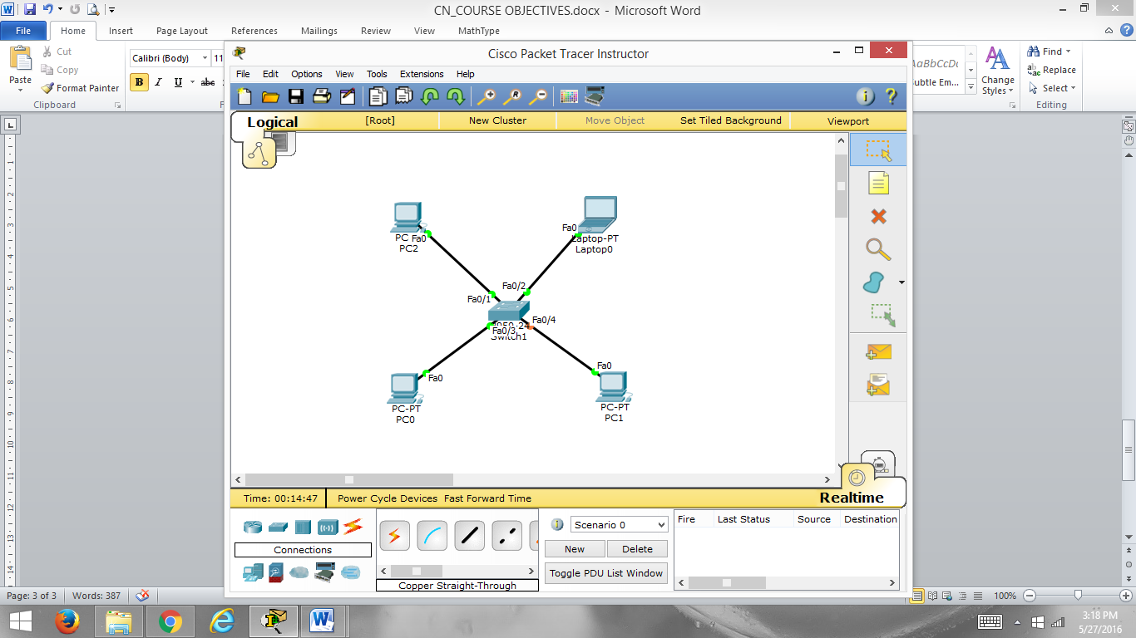 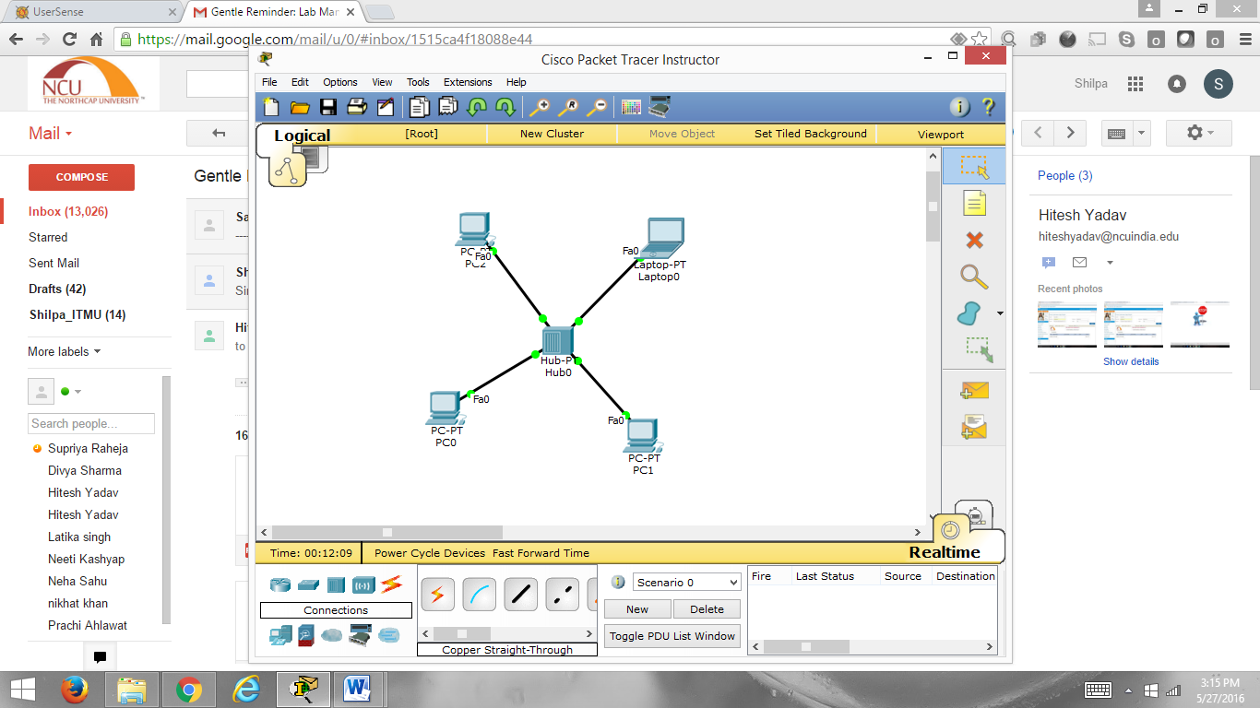

**Figure 1.1**

**Student Work Area**

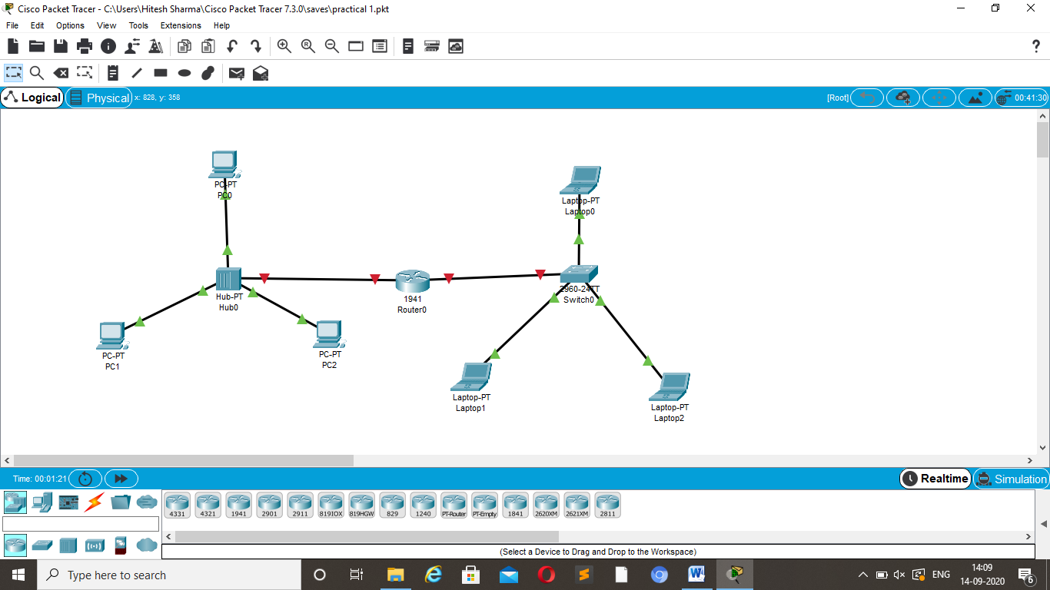

**QUESTIONS**

Q1. On what Platform Packet Tracer can be run and installed.

Ans : Packet Tracer can also be run on Linux, Microsoft Windows, and macOS. Similar Android and iOS apps are also available. Packet Tracer allows users to create simulated network topologies by dragging and dropping routers, switches and various other types of network devices.

Q2. Is the multiuser functionality fully supported in the Activity Wizard?

Ans: Multiuser functionality is supported in the Activity Wizard.

Q3. What is the current version of packet tracer we are using?

Ans : The current Cisco Packet Tracer **7.3**. 0 build number is **7.3**. 0.0838.

Q4. Which layer 1 device can be used to enlarge the area covered by a single LAN segment?

Ans : Hubs and Repeater

Q5. What is difference between Half-Duplex and Full-Duplex Communications?

Ans : in half duplex there is two way communication but one at a time

In full duplex there is two way communication and both at same time is possible

Q6. Where would you use cross and straight cable?

Ans : Usually, straight through cables are primarily used for connecting unlike devices. And crossover cables are use for connecting alike devices. Use straight through Ethernet cable for the following cabling: Switch to router.

Q7. What is difference between packet switch and circuit switch network?

Ans : Packet-switched networks move data in separate, small blocks -- packets -- based on the destination address in each packet. When received, packets are reassembled in the proper sequence to make up the message. Circuit-switched networks require dedicated point-to-point connections during calls.

Q8. Difference between hub and switch?

Hub and Switch are both network connecting devices. Hub works at physical layer and is responsible to transmit the signal to port to respond where the signal was received whereas Switch enable connection setting and terminating based on need

Q9. How many interfaces switch supports?

Ans : generally there are three (3) interface in switch

Q10. On Which layer hub operates?

Ans : hub operate in physical layer

Q11 What is the Function of ICMP Protocol?

Ans: Error Reporting

Q12. Difference between user EXEC and Privileged EXEC mode.

Q13. Which command is used to move from privileged EXEC to global configuration

mode?

Q15. In which mode show command works?

Q16. Define network topology?

Ans : **Network topology** is the way a **network** is arranged, including the physical or logical description of how links and nodes are set up to relate to each other

Q17. Explain different cable types.

Ans : Twisted pair , Coaxial , Fibre optic cable

Q18. Difference between repeater, bridge and Hub?

Ans : The key difference between hubs, switches and bridges is that hubs operate at Layer 1 of the OSI model, while bridges and switches work with MAC addresses at Layer 2. Hubs broadcast incoming traffic on all ports, whereas bridges and switches only route traffic towards their addressed destinations.

**QUIZ-1**

**Marks Obtained -------------------------**

**Maximum Marks-----------------------------**

**Experiment No: 2**

Student Name and Roll Number: Hitesh 18CSU086

Semester /Section: V-A

Link to Code:

Date:

Faculty Signature:

Remarks:

**Objective**

To Verify and Configure VLAN and VLAN trunk in packet tracer.

**Program Outcome**

Students will be able to implement and configure VLAN.

**Problem Statement**

1. Create VLAN on S1, S2, and S3.

* VLAN 10: Faculty
* VLAN 20: Guest
* VLAN 30: Students

1. Assign VLANs to the active port S2 and S3.
2. Create VLAN trunk.

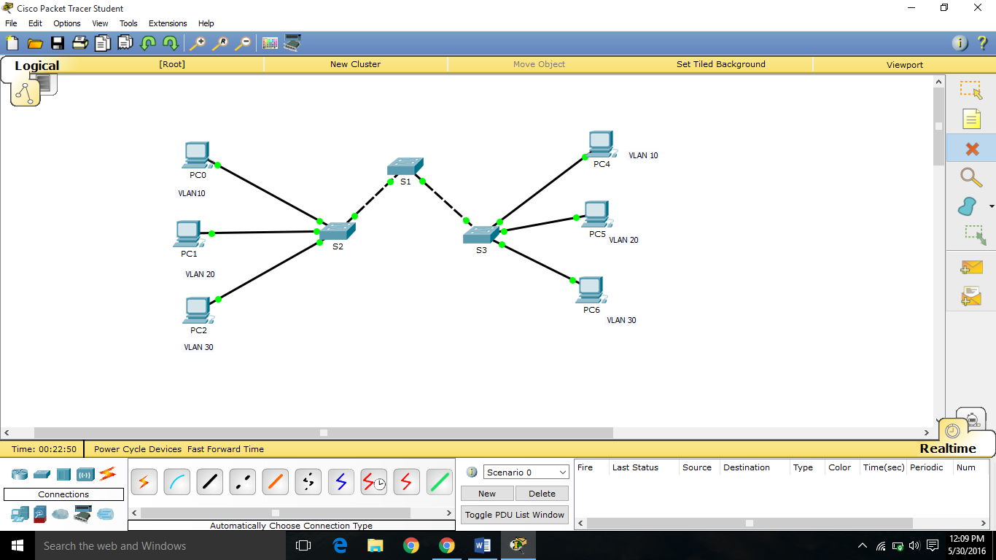

**Figure 2.1**

**Student Work Area**

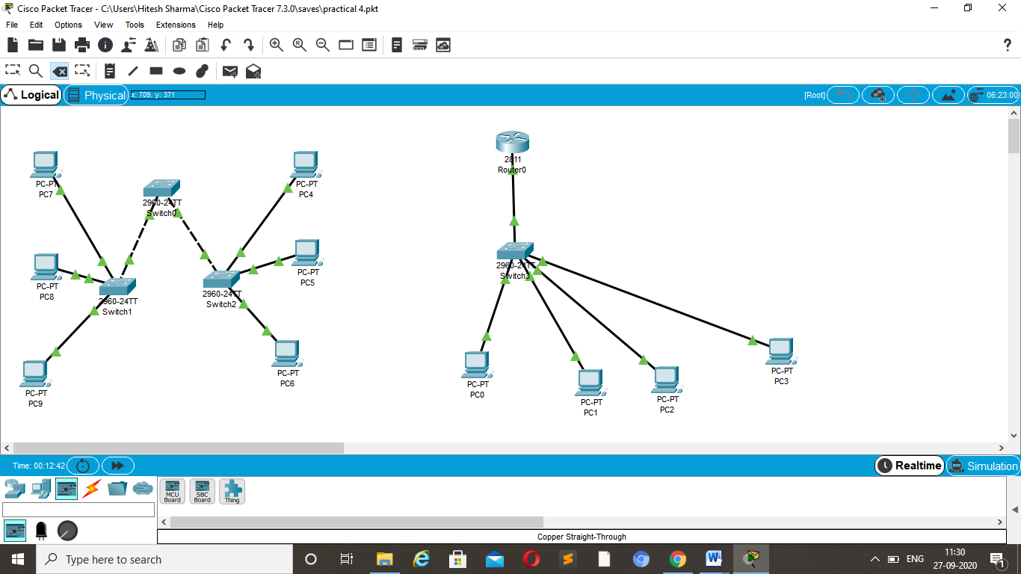

**Experiment No: 3**

Student Name and Roll Number: Hitesh 18CSU086

Semester /Section: V-A

Link to Code:

Date:

Faculty Signature:

Remarks:

**Objective**

To construct RJ45 cable.

**Program Outcome**

Students will be able to differentiate cables and their colour coding scheme.

**Problem Statement**

1. Write down different types and categories of cables.
2. Design color coding for straight through and Cross over cables and test.

**Student Work Area**

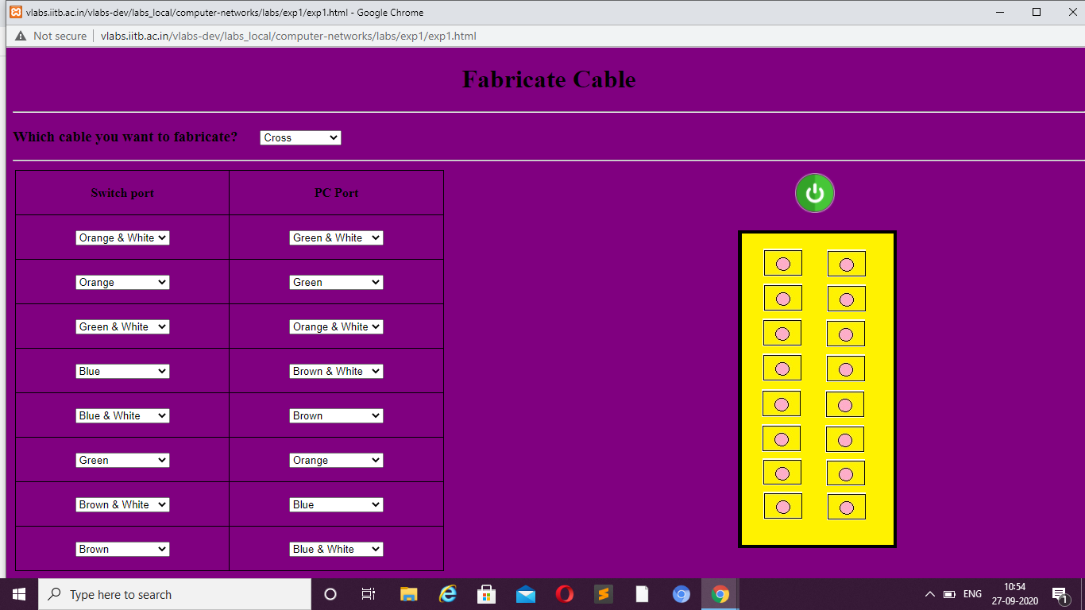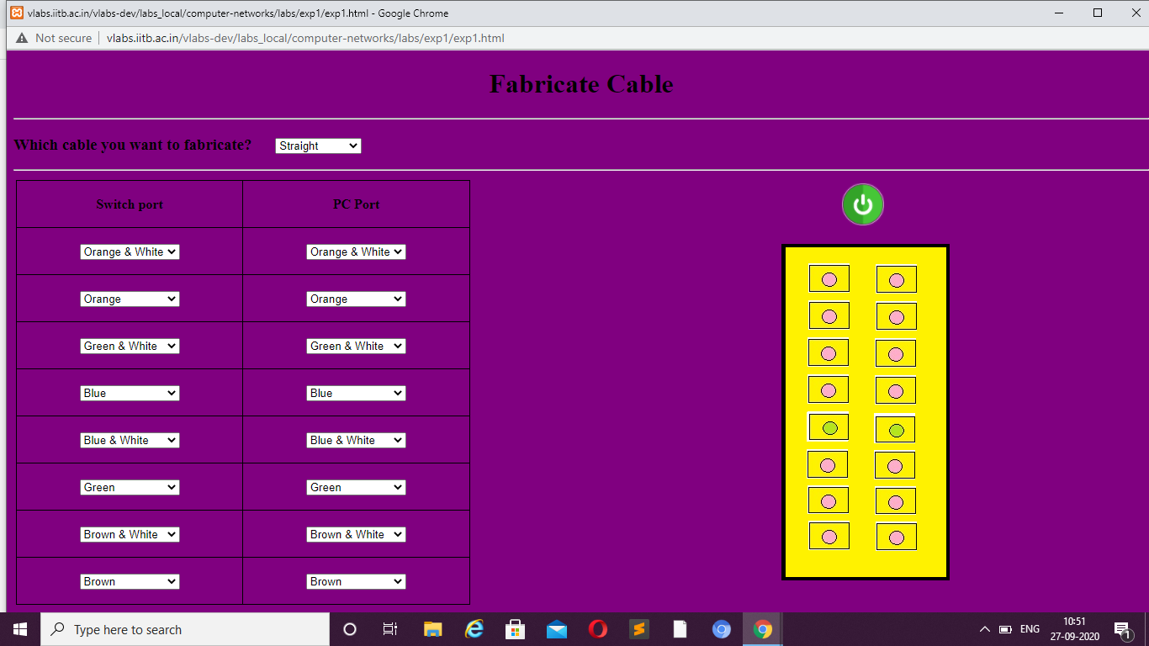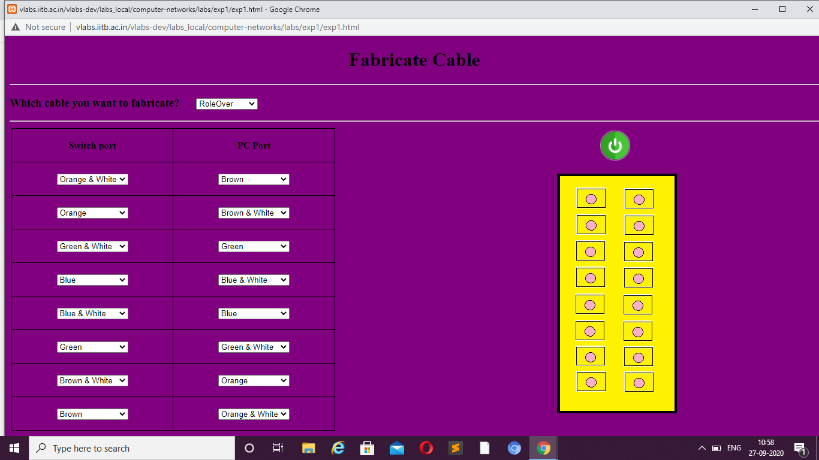

**QUESTIONS**

Q1. Which is the most popular international cable standard?

Ans : Ethernet, developed by the Electrical and Electronic Engineers Institute, IEEE **Standard** 802

Q2. Where are twisted pair cables for connection?

Ans : **Twisted**-**pair cable** is a type of **cabling** that is **used** for telephone communications and most modern Ethernet networks. A **pair** of wires forms a circuit that can transmit data.

Q3. What is the colour code of straight cable?

* Ans : White orange White Orange.
* Orange Orange.
* White Green White Green.
* Blue Blue.
* White Blue White Blue.
* Green Green

Q4. What is TIA/EIA?

Ans : ANSI/TIA-568 is a set of telecommunications standards from the Telecommunications Industry Association.

Q5. In RJ45, what is the significance of 4 and 5 in this?

Ans : The "RJ" in RJ45 stands for "registered **jack**," since it is a standardized networking interface. The "45" simply refers to the number of the interface standard.

Q6. How many pins are on the RJ45 connector?

Ans : **RJ45** is actually an 8 position 8 conductor (8P8C) modular connector

Q7. What is a crosstalk?

Ans : In electronics, crosstalk is any phenomenon by which a signal transmitted on one circuit or channel of a transmission system creates an undesired effect in another circuit or channel.

Q8. How to identify pin no. 1 in RJ45?

Ans : Look at the **RJ45** connector on a cable, holding the flat underside toward you. On the left is **pin 1**

Q9. Which tool is used to test the working of a cable ?

Ans : A **cable** tester is an electronic device **used to verify** the electrical connections in a signal **cable** or other wired assembly.

Q10.In RJ45 plug of 100BaseT,if pin no. 1 and 2 are in TRANS then which pins are used for

RECEIVE?

Q11. What is the colour code of crossover cable?

Ans : A crossover has one end with the **Orange** set of wires switched with the **Green** set.

Q12. How can one tell whether the cable is straight through or crossover?

Ans : When **you** connect two devices of different types together, **you** use a **straight through cable**. When **you** connect two devices of the same type together, **you** use a **crossover cable**.

Q13.What is the difference between shielded and unshielded pair?

Ans : The basic **difference between UTP** and STP is **UTP** (**Unshielded** twisted **pair**) is a cable with wires that are twisted together to reduce noise and crosstalk. On the contrary, STP (**Shielded** twisted **pair**) is a twisted **pair** cable confined in foil or mesh **shield** that guards the cable against electromagnetic interference.

.

**QUIZ-3**

**Marks Obtained -------------------------**

**Maximum Marks-----------------------------**

**Experiment No: 4**

Student Name and Roll Number: Hitesh 18CSU086

Semester /Section: V-A

Link to Code:

Date:

Faculty Signature:

Remarks:

**Objective**

a)To configure simple static routing.

To implement Security on interconnecting devices

**Program Outcome**

Students will be able to configure routers and implement security on different modes such as User EXEC mode, Privileged mode, and Global Configuration mode.

**Problem Statement**

Configure following topology as shown in figure 4.1

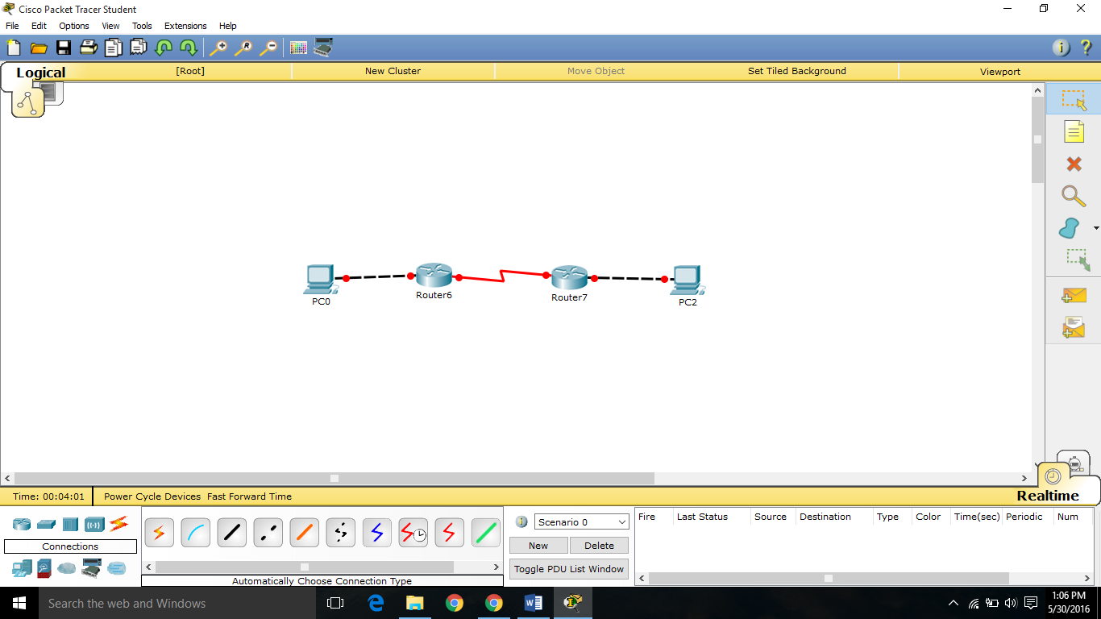

**Figure 4.1**

**Student Work Area**

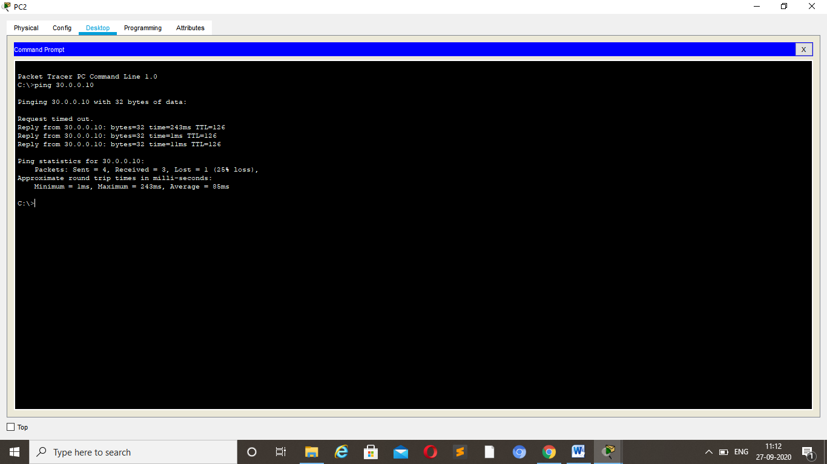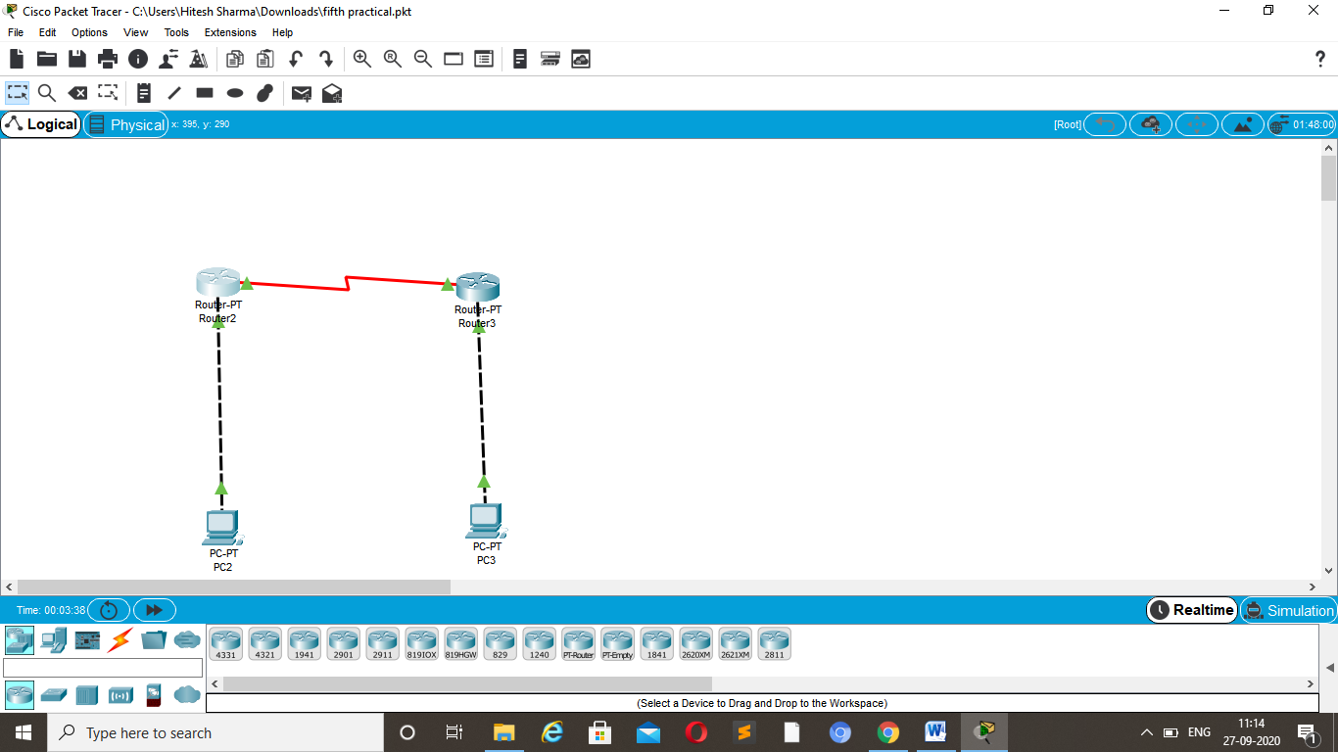



**Experiment No: 5**

Student Name and Roll Number: Hitesh 18CSU086

Semester /Section: V-A

Link to Code:

Date:

Faculty Signature:

Remarks:

**Objective**

To configure a Network Topology constitutes Routers and Switches using Packet Tracer.

**Program Outcome**

Students will be able to configure a network.

**Problem Statement**

Configure following network topology as shown in figure.

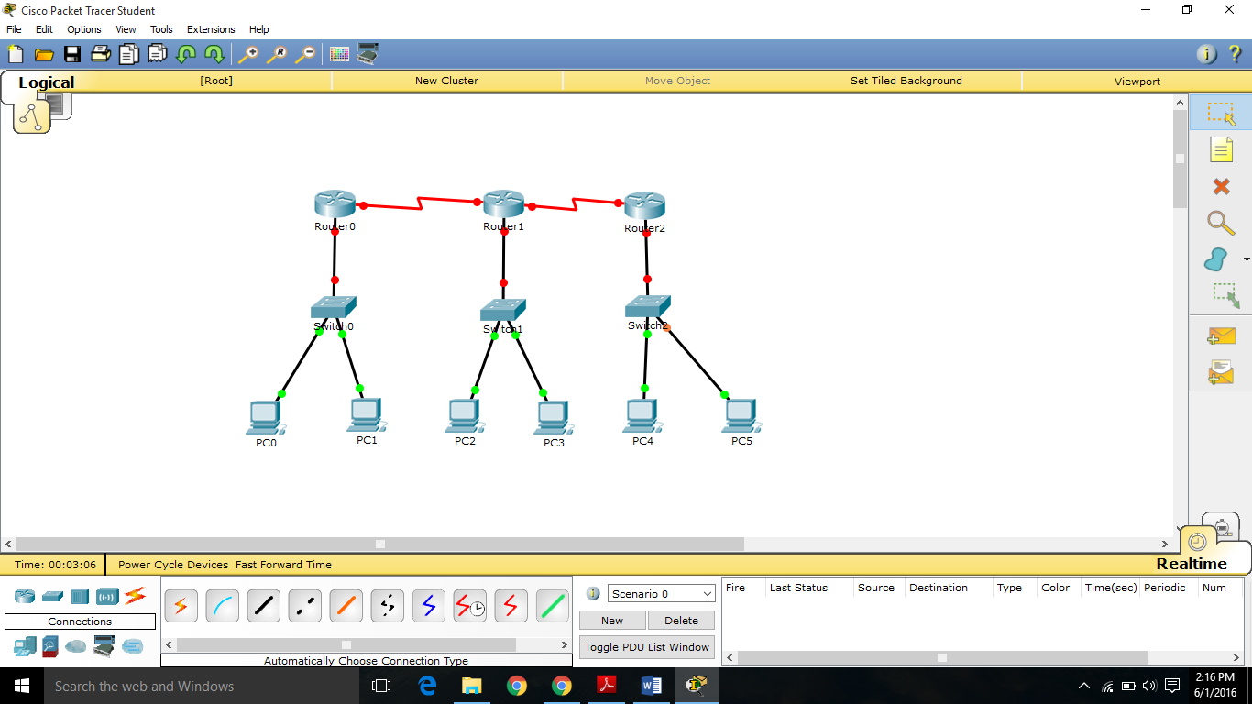

**Figure 5.1**

**Student Work Area**

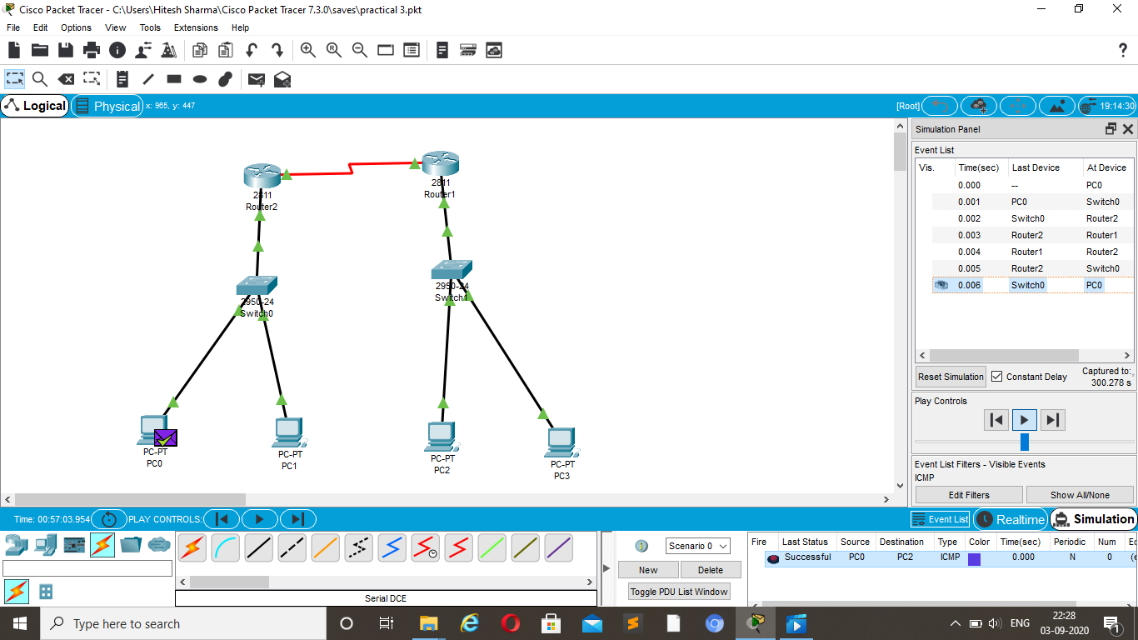

**QUESTIONS**

Q1. What is the purpose of spanning tree protocol in a switch?

Ans : The **Spanning Tree Protocol** (**STP**) is a network **protocol** that builds a loop-free logical topology for Ethernet networks.

Q2. Which switch mode do not check the CRC of the frame before sending it?

Q3. Can we use serial cable connection on the router directly?

Ans : There is usually a fiber device installed by the service provider and an Ethernet **cable** from which it goes to the **router**. So using **serial** interfaces for new **connections** is now less common, they are still loads out there though.

Q4. What are the different memories used in a CISCO router?

Ans : At the hardware level, there are four main types of Cisco memory: DRAM, EPROM, **NVRAM**, and Cisco **Flash Memory**. DRAM, or **Dynamic Random Access Memory**

Q5. How are internetworks created?

Ans : By connecting multiple networks to a router, you **create** an **internetwork**. ... Notice how both LANs and WANs are connected to a router.

Q6. In configuring a router, what command must be used if you want to delete the configuration data that is stored in the NVRAM?

Ans : The **command erase** startup-**config** deletes the **configuration stored** in **NVRAM**.

Q7. The Internet Control Message Protocol occurs at what layer of the seven layer model?

Ans : Network

Q8.In a router, what is default route used for?

Ans : In computer networking, the **default route** is a configuration of the Internet Protocol (IP) that establishes a forwarding rule for packets when no specific address of a next-hop host is available from the **routing** table or other **routing** mechanisms.

Q9. In a network of routers and switches, what is the difference between routing and switching?

Ans : The most basic explanation is that a **switch** is designed to connect computers within a **network**, while a **router** is designed to connect multiple **networks** together. ... Even though **routers and switches** are **different**, they can be used interchangeably. For example, a **router** typically has several LAN ports and a single WAN port.

Q10.What QoS parameters are required to transfers credential file from one source to a destination?

Ans : The main **QoS parameters required** is Bandwidth and Data loss.

Q11.What are unicast frames?

Ans : A **unicast frame** contains the unique MAC address of the destination receiver. A broadcast **frame** contains all binary 1's as the destination address (FFFF. ... A **unicast** addressed **frame** is only sent out the specific port leading to the receiver

Q12.What are some network devices that operate at the data link layer?

Ans : Two types of Data Link layer devices are commonly used on networks: **bridges** and **switches**. A **bridge** is an intelligent **repeater** that is aware of the MAC addresses of the nodes on either side of the **bridge** and can forward **packets** accordingly

Q13. Differtiate logical topology from physical topology.

Ans : A **physical topology** is how they are actually interconnected with wires and cables. For example, in a shared Ethernet network that uses hubs rather than switches, the **logical topology** appears as if every node is connected to a common bus that runs from node to node

Q14. Which command is used to copy RAM to NVRAM.

Ans : To copy the running-config to NVRAM so that it will be used if the router is restarted, use the **copy running-config startup-config command**

Q15. What is the significance of IP ROUTE command?

Ans : **IP route command** is used to configure the **static route**. **Static routes** are the most secure way of routing. They will also increase overall network performance.

Q16. What is the job of the Network Layer under the OSI reference model?

Ans : Located at **Layer** 3 of the Open Systems Interconnection (**OSI**) communications **model**, the **network layer's** primary **function** is to move data into and through other networks.

Q17. How can you identify the IP class of a given IP address?

Ans : You can do it by looking at the first octet of the **IP address**. Convert the dotted-decimal **IP address** to its binary equivalent. If it begins with 0, then it's a **Class** A network. If it begins with 10, then it's a **Class** B network

Q18. What is the use of a default gateway?

Ans : The **default gateway** is the path used to pass information when the device doesn't know where the destination is.

Q19. You need to connect two computers for file sharing. Is it possible to do this without using a hub or router?

Ans : Yes, its **possible** to **connect two** computer **without hub** and **router**. **We** can use cross cable to **connect** both computer

Q20. How are IP addresses arranged and displayed?

Ans : **IP addresses** are **displayed** as a series of four decimal numbers that are separated by period or dots.

**QUIZ-5**

**Marks Obtained -------------------------**

**Maximum Marks----------------------------**

**Experiment No: 6**

Student Name and Roll Number: Hitesh 18CSU086

Semester /Section: V-A

Link to Code:

Date:

Faculty Signature:

Remarks:

**Objective**

Working with complex network topologies.

**Program Outcome**

Student will learn to work with complex network configurations.

**Problem Statement**

1. Configure network topology using file server as shown in figure 5.1

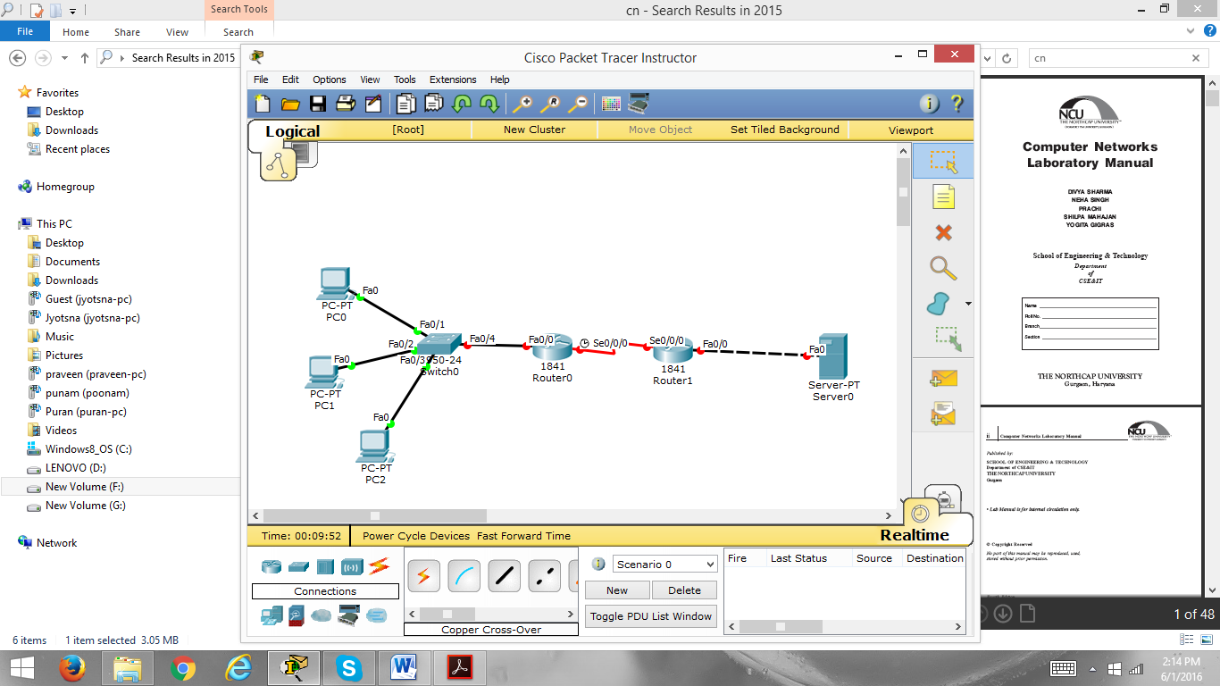

**Figure 6.1**

1. Configuring Wireless LAN Access

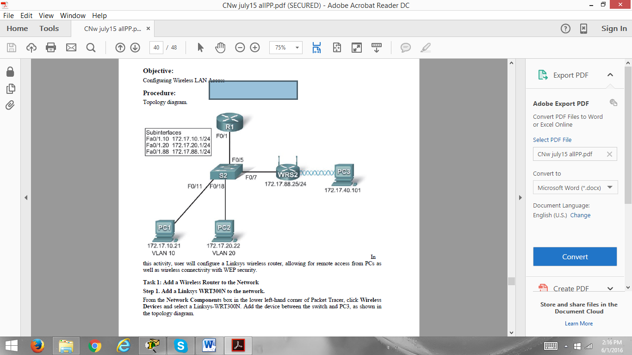

**Figure 6.2**

**Student Work Area**

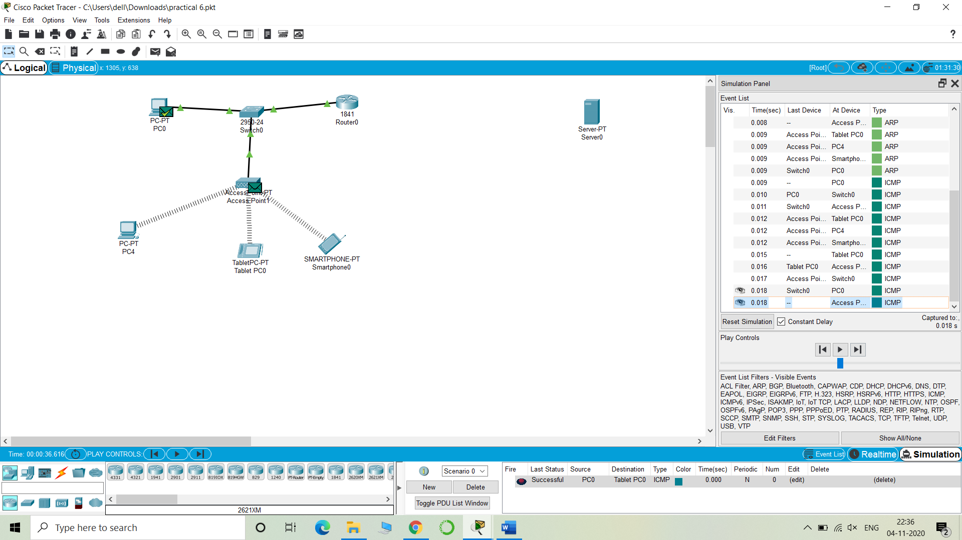

**Experiment No: 7**

Student Name and Roll Number: Hitesh 18CSU086

Semester /Section: V-A

Link to Code:

Date:

Faculty Signature:

Remarks:

**Objective**

Mid Term Evaluation.

**Faculty Remarks:**

**Experiment No: 8**

Student Name and Roll Number:Hitesh 18CSU086

Semester /Section: V-A

Link to Code:

Date:

Faculty Signature:

Remarks:

**Objective**

To monitor network traffic using Wire shark

**Program Outcome**

Student will able to analyze different field of TCP header.

**Problem Statement**

1. Installation of Wire shark.
2. Network monitoring on Wire shark

**Student Work Area**

**QUESTIONS**

[Q1. What devices can Wireshark use to capture packets?](https://www.wireshark.org/faq.html#q1.13)

Q2.[Does Wireshark work on Windows Vista or Windows Server 2008?](https://www.wireshark.org/faq.html#q1.14)

Q3. [What exactly does Wireshark do?](http://ask.brothersoft.com/what-exactly-does-wireshark-do-1519.html)

Q4. Is Wireshark freely available or not?

Q5. Can Wireshark be used on LINUX?

Q6. A user is unable to ping a system on the network. How can wireshark be used to solve the problem?

Q7. Which Wireshark filter can be used to check all incoming requests to a HTTP Web server?

Q8. Which Wireshark filter can be used to monitor outgoing packets from a specific system on the network?

Q9. Is it possible to start Wireshark from command line on Windows?

Q10. What others tools can be used for network analysis.

Q11. Why network analysis is required?

Q12. What are the fields of TCP header?

**QUIZ-8**

**Marks Obtained -------------------------**

**Maximum Marks---------------------------**

**Experiment No: 9**

Student Name and Roll Number: Hitesh 18CSU086

Semester /Section: V-A

Link to Code:

Date:

Faculty Signature:

Remarks:

**Objective**

To get the MAC or Physical Address of the system Using Address Resolution Protocol.

**Program Outcome**

Students will be able to learn functionality of ARP and ICMP protocols

**Problem Statement**

Configure a following topology as shown in figure 9.1

* Gets MAC address of the system using ARP protocol?
* Show ICMP Packet format and analyse its behaviour.

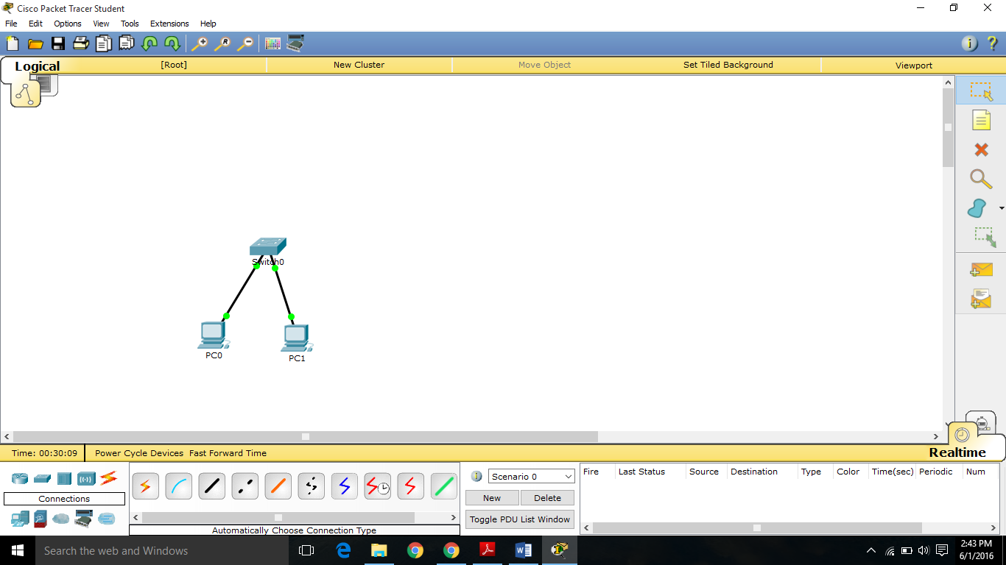

**Figure 9.1**

**Student Work Area**

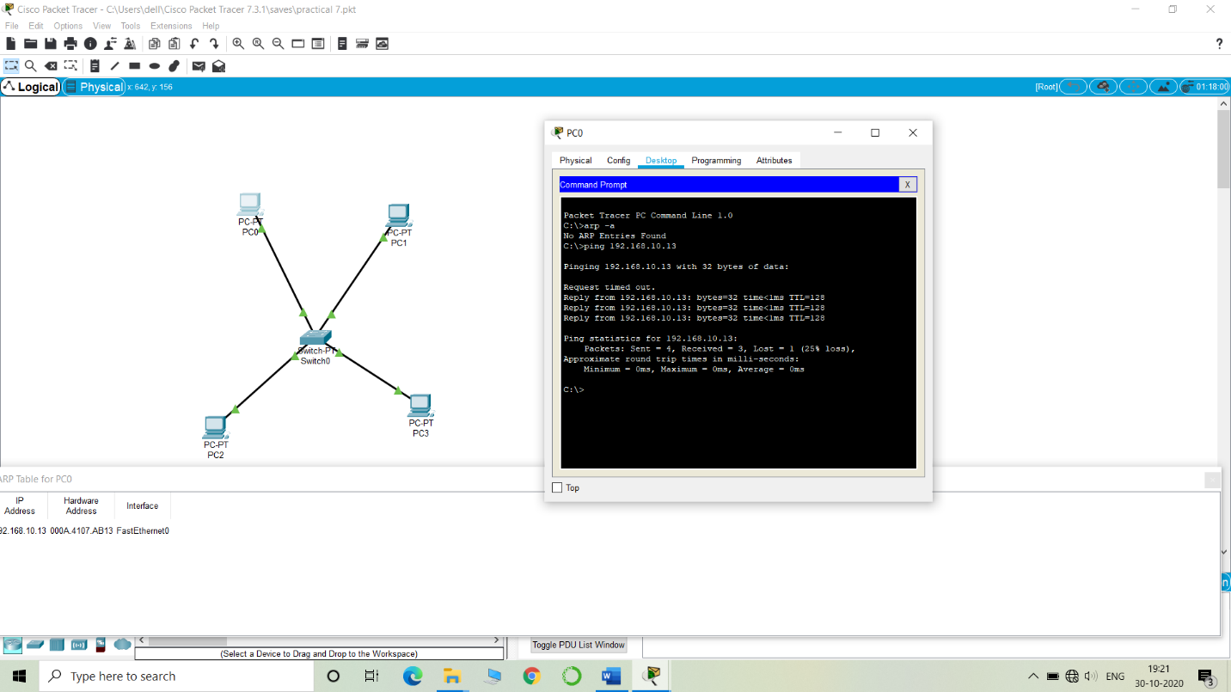

**Experiment No: 10**

Student Name and Roll Number: Hitesh 18CSU086

Semester /Section:V-A

Link to Code:

Date:

Faculty Signature:

Remarks:

**Objective**

Configure network using Routing Information Protocol (RIP)

**Program Outcome**

To configure RIP on all the devices and test for ping and trace commands

**Problem Statement**

Configure the following topology as shown in Figure 10.1

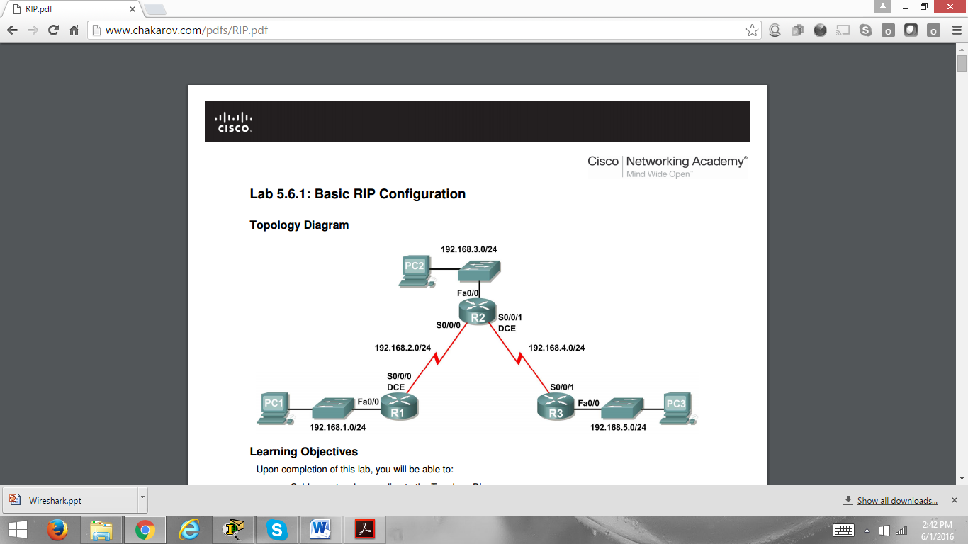

**Figure 10.1**

**Student Work Area**

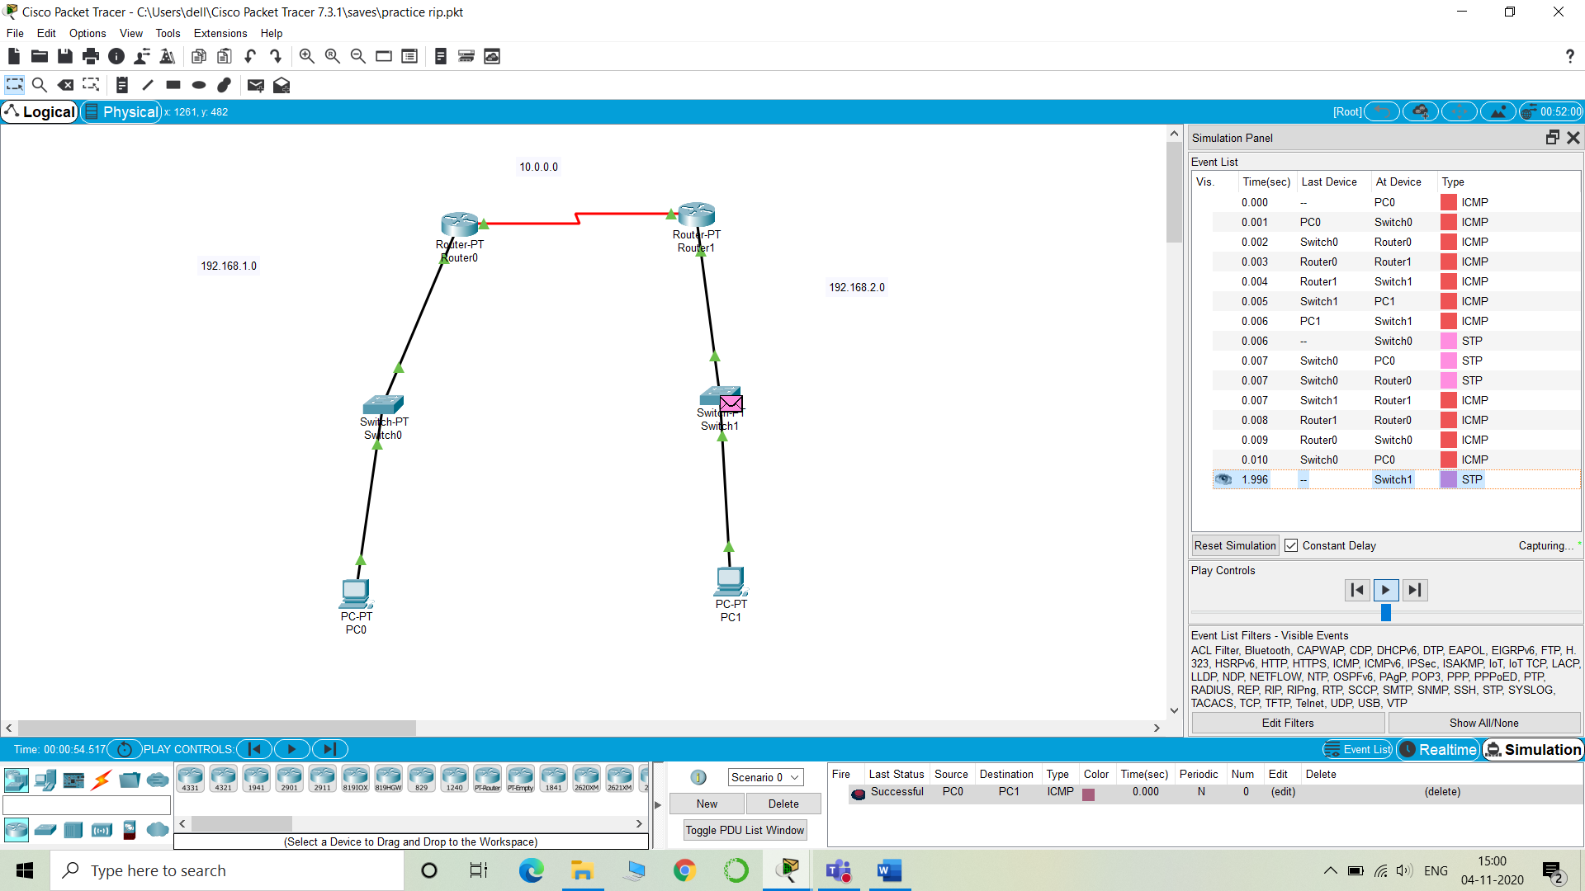

**QUESTIONS**

**Q1.** What is the full form of RIP?

**Q2.** What is the destination IP address of a Rip v1 packet?

**Q3.** If a static route and a Rip learnt route is available on a router which entry would be chosen by the router to forward the packet?

**Q4.** What is the major benefit of dynamic routing protocol like RIP over Static route?

**Q5.** What is the administrative distance of Ripip?

**Q6.** Can we use RIP in a scenario having 15 routers?

**Q7.** Utilizing RIP, what is the limit on number of hops ?

**Q8.** RIP uses UDP or TCP?

**Q9.** What is the difference between RIPv1 and RIPv2?

**Q10.** How does RIP differs from IGRP?

**Q11**. What route entry will be assigned to dead or invalid route in case of RIP?

**Q12.** Multiple Choice Questions

RIP defines two types of messages:

 LSA

 Hello message

 Response Message

 Request Message

**Q13.** On what basis best path in RIP decided?

**Q14.** How local information is shared in RIP?

**Q15.** What is the use of RIP?

**QUIZ-10**

**Marks Obtained -------------------------**

**Maximum Marks----------------------------**

**Experiment No: 11**

Student Name and Roll Number: Hitesh 18CSU086

Semester /Section: V-A

Link to Code:

Date:

Faculty Signature:

Remarks:

**Objective**

To configure network state routing protocol (OSPF)

**Program Outcome**

To configure OSPF on all the devices and test for ping and trace commands.

**Problem Statement**

Configure following topology as shown in Figure 11.1

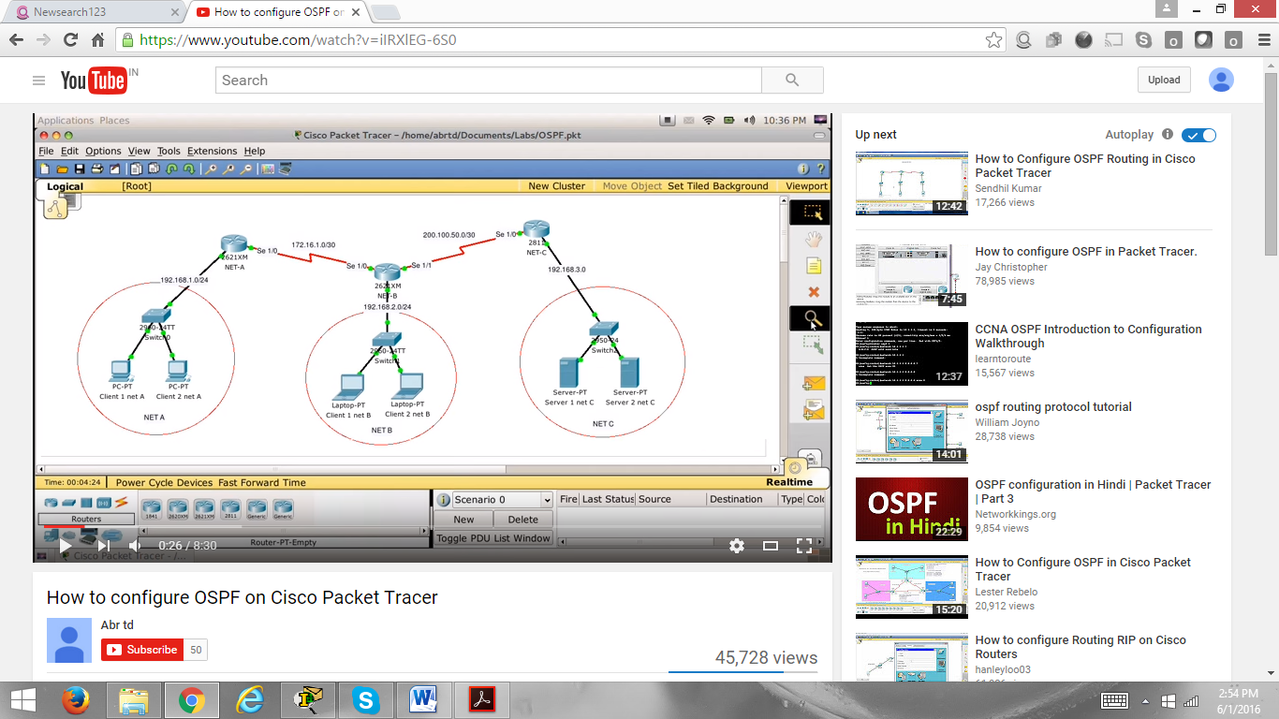

**Figure 11.1**

**Student Work Area**

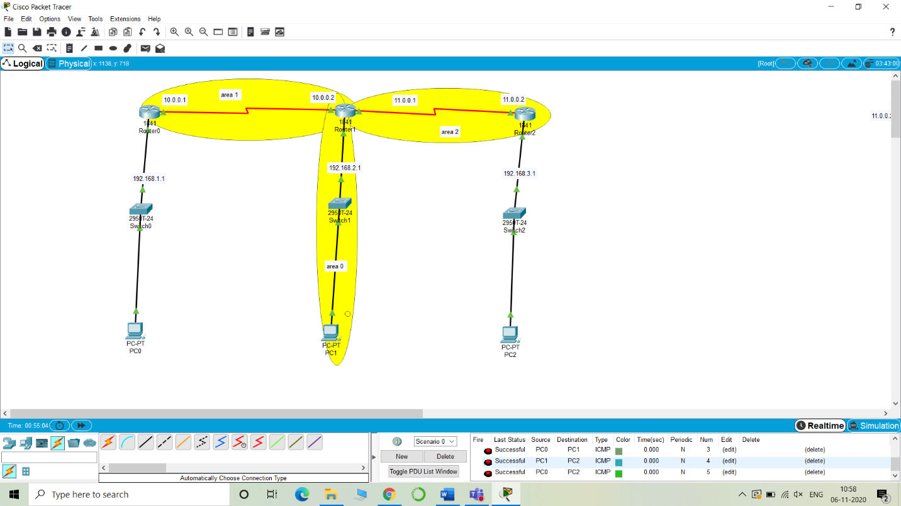

**Experiment No: 12**

Student Name and Roll Number: Hitesh 18CSU086

Semester /Section: V-A

Link to Code:

Date:

Faculty Signature:

Remarks:

**Objective**

To configure Border Gateway Protocol.

**Program Outcome**

To configure BGP on all the devices and test for ping command.

Configure following topology as shown in figure 12.1.

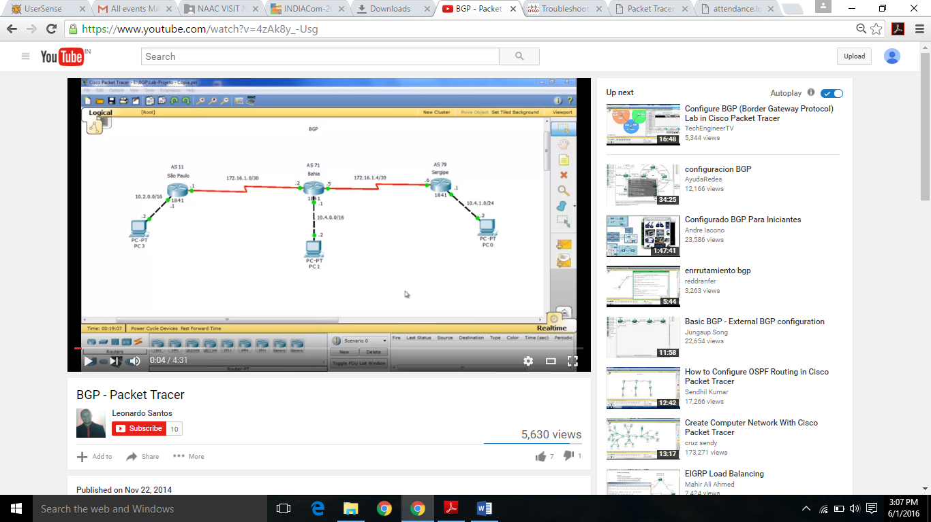

Figure 12.1

**Student Work Area**

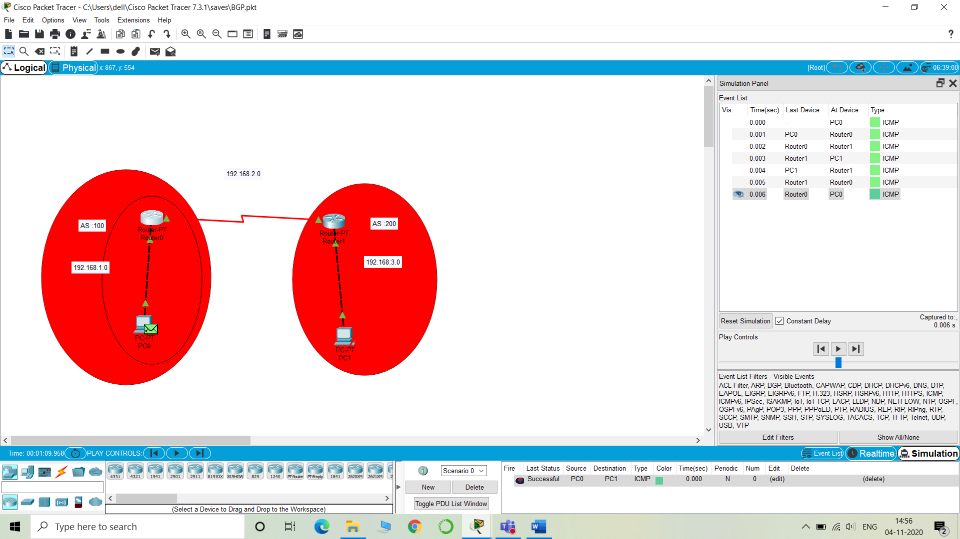

**QUESTIONS**

Q1. [How do I configure BGP?](http://www.cisco.com/c/en/us/support/docs/ip/border-gateway-protocol-bgp/5816-bgpfaq-5816.html#qa)

Q2. [What is the order of preference of attributes when some or all are applied to one neighbor in BGP?](http://www.cisco.com/c/en/us/support/docs/ip/border-gateway-protocol-bgp/5816-bgpfaq-5816.html#one)

Ans : The order of preference varies based on whether the attributes are applied for inbound updates or outbound updates. For inbound updates the order of preference is: route-map.

Q3. [What does a next hop of 0.0.0.0 mean in the show ip bgp command output?](http://www.cisco.com/c/en/us/support/docs/ip/border-gateway-protocol-bgp/5816-bgpfaq-5816.html#two)

Ans : The 0.0. 0.0 means the route was locally originated through the network command or aggregate-address command

Q4. [What are the well known communities of the BGP community attribute?](http://www.cisco.com/c/en/us/support/docs/ip/border-gateway-protocol-bgp/5816-bgpfaq-5816.html#three)

Ans : Internet: advertise the prefix to all BGP neighbors.

No-Advertise: don't advertise the prefix to any BGP neighbors.

No-Export: don't advertise the prefix to any eBGP neighbors.

Local-AS: don't advertise the prefix outside of the sub-AS

Q5. [What formats can I use to configure the BGP community attribute?](http://www.cisco.com/c/en/us/support/docs/ip/border-gateway-protocol-bgp/5816-bgpfaq-5816.html#four)

Ans : In Cisco IOS Software Release 12.0 and later, we can configure communities in three different formats: Decimal. Hexadecimal.

Q6. [How does BGP behave differently with auto-summary enabled or disabled?](http://www.cisco.com/c/en/us/support/docs/ip/border-gateway-protocol-bgp/5816-bgpfaq-5816.html#five)

Ans : When auto-summary is enabled, it summarizes the locally originated BGP networks to their classfull boundaries. (Auto-summary is enabled by default in BGP). When auto-summary is disabled, the routes introduced locally into the BGP table are not summarized to their classfull boundaries.

Q7. [When and how should I reset a BGP session?](http://www.cisco.com/c/en/us/support/docs/ip/border-gateway-protocol-bgp/5816-bgpfaq-5816.html#seven)

Ans To reset a BGP connection using BGP soft reconfiguration, use the clear ip bgp command in EXEC Privilege mode at the system prompt

Q8. [What is the BGP path selection criteria?](http://www.cisco.com/c/en/us/support/docs/ip/border-gateway-protocol-bgp/5816-bgpfaq-5816.html#nine)

Ans Choose the route with the highest weight. ... Choose the route with the lowest MED, if the same Autonomous System advertises the possible routes. Choose an EBGP route over an IBGP route. Choose the route through the nearest IGP neighbor as determined by the lowest IGP metric

Q9. [Do internal BGP (iBGP) sessions modify the next hop?](http://www.cisco.com/c/en/us/support/docs/ip/border-gateway-protocol-bgp/5816-bgpfaq-5816.html#eleven)

Ans All routers within an autonomous system are assumed to be able to reach the same set of subnets (advertised through IGP). Consequently, when an AS edge router propagates external BGP prefixes to internal BGP peers, it does not change the BGP next hop

Q10.[How can I configure BGP to provide load sharing and redundancy in my network?](http://www.cisco.com/c/en/us/support/docs/ip/border-gateway-protocol-bgp/5816-bgpfaq-5816.html#sixteen)

Q11. [Why do I see the same route twice form the same peer in BGP ? For example:](http://www.cisco.com/c/en/us/support/docs/ip/border-gateway-protocol-bgp/5816-bgpfaq-5816.html" \l "qbgp)

[64512 28513 8151 65194 65230 65085](http://www.cisco.com/c/en/us/support/docs/ip/border-gateway-protocol-bgp/5816-bgpfaq-5816.html" \l "qbgp)

[169.185.119.90 from 169.185.119.90 (153.40.61.128)](http://www.cisco.com/c/en/us/support/docs/ip/border-gateway-protocol-bgp/5816-bgpfaq-5816.html" \l "qbgp)

[Origin IGP, localpref 200, valid, external](http://www.cisco.com/c/en/us/support/docs/ip/border-gateway-protocol-bgp/5816-bgpfaq-5816.html" \l "qbgp)

[Community: 100:2 28513:1281](http://www.cisco.com/c/en/us/support/docs/ip/border-gateway-protocol-bgp/5816-bgpfaq-5816.html" \l "qbgp)

[64512 28513 8151 65194 65230 65085, (received-only)](http://www.cisco.com/c/en/us/support/docs/ip/border-gateway-protocol-bgp/5816-bgpfaq-5816.html" \l "qbgp)

[169.185.119.90 from 169.185.119.90 (153.40.61.128)](http://www.cisco.com/c/en/us/support/docs/ip/border-gateway-protocol-bgp/5816-bgpfaq-5816.html" \l "qbgp)

[Origin IGP, localpref 100, valid, external](http://www.cisco.com/c/en/us/support/docs/ip/border-gateway-protocol-bgp/5816-bgpfaq-5816.html" \l "qbgp)

[Community: 28513:1281](http://www.cisco.com/c/en/us/support/docs/ip/border-gateway-protocol-bgp/5816-bgpfaq-5816.html" \l "qbgp)

Ans : Two entries are seen due to soft-reconfiguration configured. Both the unmodified path and the modified path, which depends on the inbound policy, if permitted, are stored in the path table for the prefix.

Q12. [How do I verify Layer 4 forwarding summary information?](http://www.cisco.com/c/en/us/support/docs/ip/border-gateway-protocol-bgp/5816-bgpfaq-5816.html#l4)

Ans : In order to view the summary information on Layer 4 forwarding, use the **show mls cef summary** command

Q13. While selecting the bset path, what are the attributes taken into consideration by BGP?

Ans : Prefer the highest local-preference value.

Prefer the shortest AS-path length.

Prefer the lowest origin value.

Prefer the lowest MED value.

Prefer routes learned from an EBGP peer over an IBGP peer.

Prefer best exit from AS.

For EBGP-received routes, prefer the current active route.

Q14. Which TCP port BGP uses?

Ans : Among routing protocols, BGP is unique in using TCP as its transport protocol. BGP peers are established by manual configuration between routing devices to create a TCP session on port 179.

Q15. Which version of BGP you are currently using?

Ans : The current version of BGP is version 4 (BGP4), which was published as RFC 4271 in 2006

**QUIZ-12**

**Marks Obtained -------------------------**

**Maximum Marks----------------------------**

**Experiment No: 13**

Student Name and Roll Number: Hitesh 18CSU086

Semester /Section: V-A

Link to Code:

Date:

Faculty Signature:

Remarks:

**Objective**

To configure Application Layer protocols: DHCP and DNS.

**Program Outcome**

Student will learn to set domain name and dynamically assigning of IPs.

**Problem Statement**

Configure following topology as shown in Figure 10.1

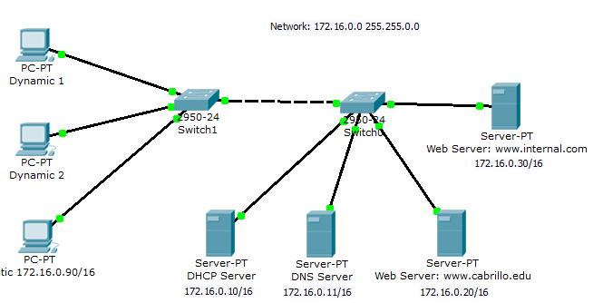

Figure 13.1

**Student Work Area**

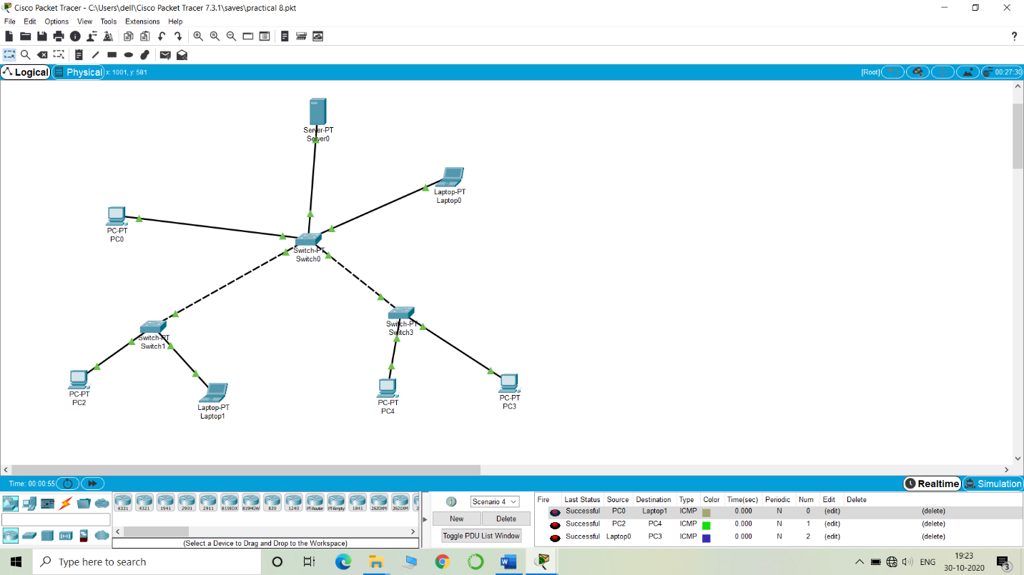

**Experiment No: 14**

Student Name and Roll Number: Hitesh 18CSU086

Semester /Section: V-A

Link to Code:

Date:

Faculty Signature:

Remarks:

**Objective**

End Term Evaluation.

**Faculty Remarks:**